to pull tomcat image fro docker hub

Download a docker image from hub.docker.com

docker image pull <image_name>:<image_version/tag>

* docker pull tomcat:latest

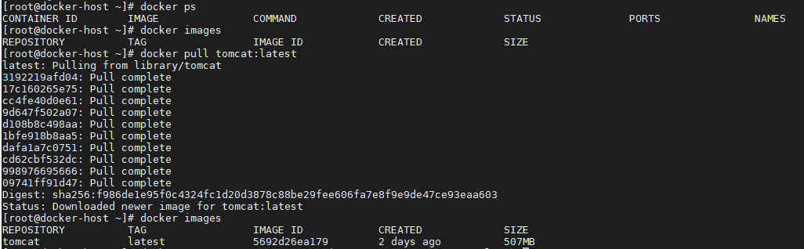

|  |
| --- |
| Creation of container with image |
|  |

* docker run --name <container_Name> -p<internal port:external port><image_name>:<image_version/tag>

docker run --name tomcat-container - p 8080:8080 tomcat:latest

dokcer run –d –name tomcat-container –p 8080:8080 tomcat:latest

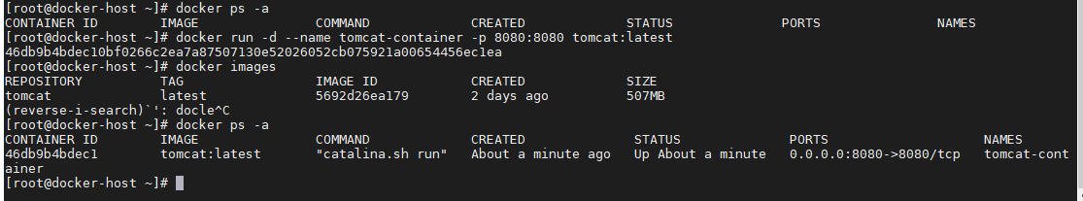

to remove the container

* docker rm <container ID/ container name>

if you encounter this below error

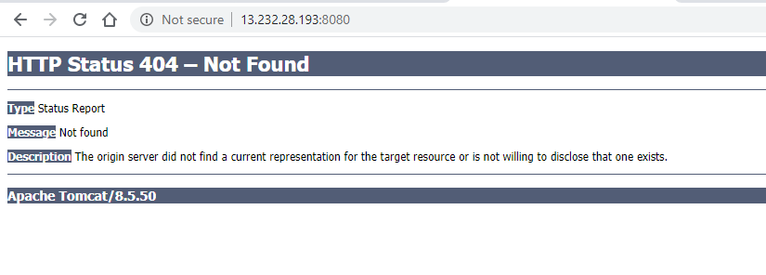

1. login to a docker container

docker exec -it <container_Name> /bin/bash



Navigate to webapps folder and check is any folders are there or not. If there is no folder in webapps then navigate to webapps.dist folder location and check

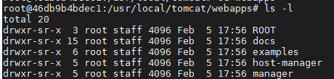

If you find any folders in webapps.dist folder move all folders to webapp by using below command

* cp –R * ../webapps
* 

**Integrating docker with Jenkins**

**Install the plugin (publish over ssh)**

**Manage Jenkins> pulgins> publish over ssh**

* **After this we need to create a user in docker host server** 
  + 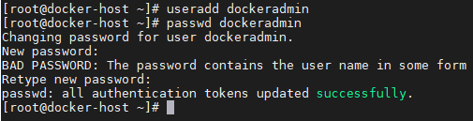
  + **Cat /etc/group**
  + 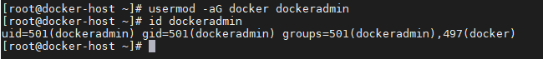
* **Now go back to jenkins server and click on >manage Jenkins>configure systems**
* 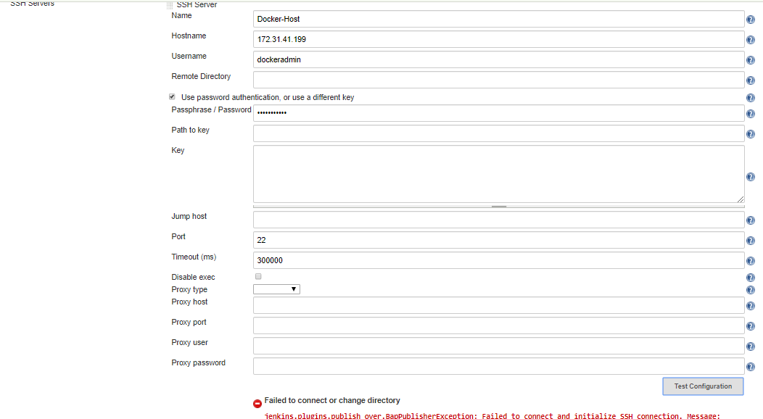**we are getting above connection error. To remove that error we need to navigate to** 
  + **Vi /etc/ssh/ssh_config**
  + **In this file we need to edit** 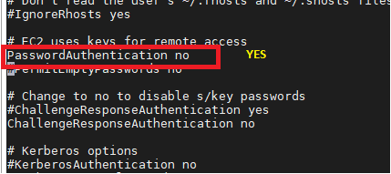
  + **Type > “service sshd reload” to restart the ssh services.**
  + **Come to Jenkins server APPLY AND SAVE.**

**JENKINS JOB TO COPY THE ARTIFACTS ON TO DOCKERHOST**

**Create a new item**

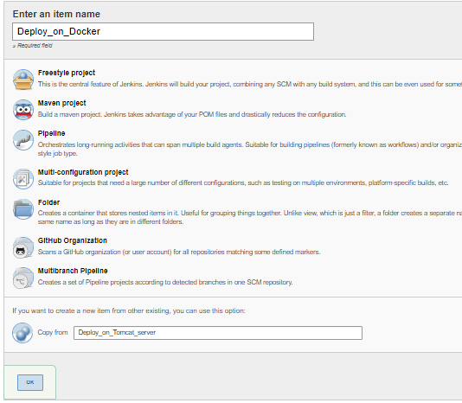

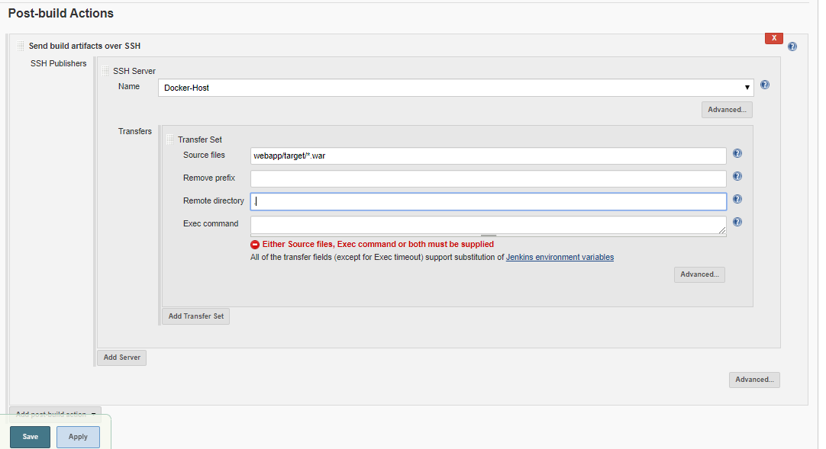

**After building the job, you will find the webapp.war file . after removing the prefix webapp/target .you need to remove the existing files and run the job.**

